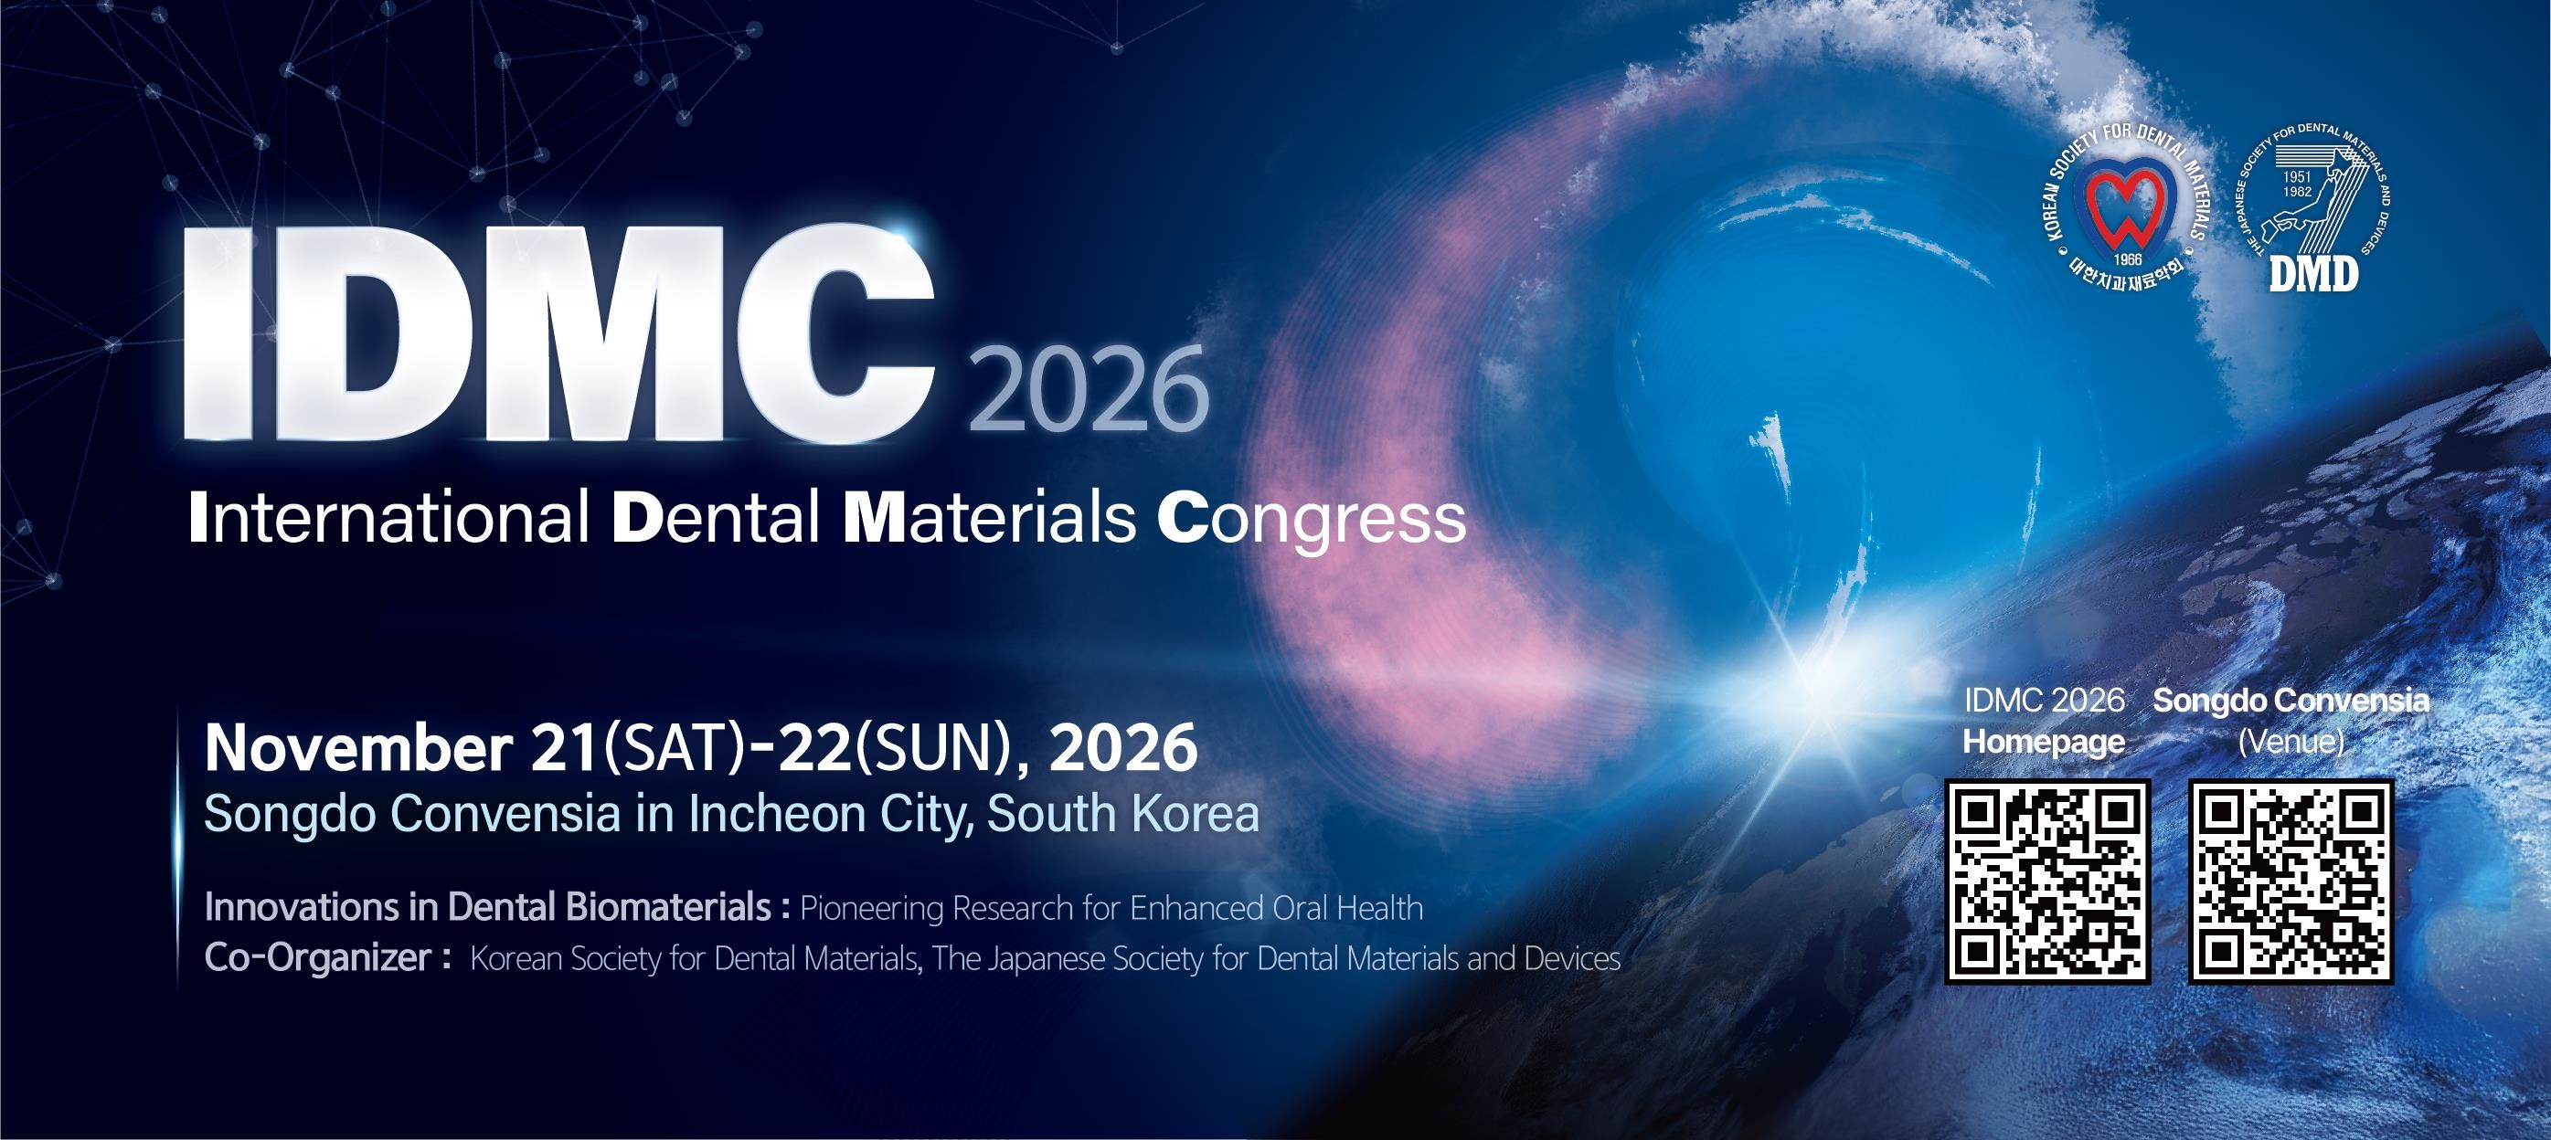

VERIFICATION FORM FOR STUDENT IDMC 2026 CONFERENCE REGISTRATION

FIRST NAME: LAST NAME: ADDRESS:
ADDRESS:
CITY: STATE: ZIP: COUNTRY:

STUDENT CLASSIFICATION FOR IDMC 2026 CONFERENCE REGISTRATION
Student option is only valid if you are currently enrolled as a student in an accredited education program

Note: Individuals who already hold a PhD degree are not eligible for Student Registration.
Please send a confirmation letter of your student status from your learning institutions and provide this completed form.

Projected Graduation Date: / (Month/Year) Please attest the following by checking the applicable boxes:
- I do not have a PhD title
- I am enrolled in a Masters, PhD, or dental degree program Student Signature:

PROGRAM DIRECTOR/ADVISOR: PHONE#: E-MAIL:
Program Director/Advisor Signature:

Please return form to: IDMC 2026 Organization Committee
Email: idmc2026@gmail.com

